Deep Learning Approaches for Image Captioning: A Review of CNN and Transformer Models
Ali Hamza
Registration Number: B23F0063AI106
Zarmeena Jawad
Registration Number: B23F0115AI125
Department of Artificial Intelligence
Pak-Austria Fachhochschule Institute of Applied Sciences and Technology
Course Title: Digital Image Processing
Course Code: COMP-342
Instructor: Mr. Hussan Ali Shah
Submission Date: 3rd March 2026

Abstract
Image captioning is an important research problem in digital image processing that focuses on automatically generating meaningful and natural language descriptions for images. This task requires the integration of visual perception and linguistic understanding, making it a challenging problem at the intersection of computer vision and natural language processing. Traditional image captioning systems relied on handcrafted features and rule-based sentence generation, which limited their ability to generalize across diverse visual scenes. With the emergence of deep learning, particularly Convolutional Neural Networks (CNNs) and Transformer-based models, significant improvements have been achieved in caption accuracy, fluency, and semantic relevance.
Recent research has emphasized the use of CNNs for visual feature extraction and Transformers for sequence modeling due to their attention mechanisms and ability to capture long-range dependencies. This literature review analyzes recent research articles published between 2020 and 2024 that focus on CNN and Transformer-based image captioning approaches. The review summarizes the methods used, datasets, evaluation metrics, key results, and limitations, presents a comparative analysis, identifies research gaps, and discusses potential future directions for improving image captioning systems.
Table of Contents
Abstract i
Table of Figures iv
1. Proposed Methodology 1
1.1 Problem Definition and Research Objective 1
Research Gap 1
Objective 1
Measurable Targets 1
1.2 Data Collection and Dataset Description 2
Dataset Overview 2
Why MS COCO? 2
1.3 Data Preprocessing and Augmentation 2
Purpose 2
Image Preprocessing 2
Data Augmentation (Training Phase Only) 2
Caption Processing 3
2. Feature Extraction Module 3
2.1 CNN Backbone 3
Justification 3
Feature Extraction Process 3
Dimensional Transformation 3
3. Caption Generation Module 4
3.1 Transformer Decoder Architecture 4
Architecture Configuration 4
Input 4
Output 4
4. Training Framework 5
4.1 Training Configuration 5
5. Validation and Evaluation 5
5.1 Evaluation Metrics 5
Acceptance Thresholds 6
Statistical Validation 6
6. Error Analysis and Interpretability 6
Failure Analysis 6
Interpretability Techniques 7
7. Deployment Strategy 7
7.1 Inference Pipeline 7
7.2 Deployment Configuration 7
8. Timeline and Milestones 7
9. Risk Assessment and Mitigation 8
10. Overall System Architecture (Complete Flow) 9
11. Conclusion 9

Table of Figures
Figure 1 CNN-based visual feature extraction pipeline. 4
Figure 2: Transformer-based caption generation module. 5
Figure 3 Training loop showing loss computation and optimization. 5
Figure 4 Evaluation framework for caption quality assessment. 6
Figure 5 Inference pipeline for deployment. 7
Figure 6 Complete hybrid CNN–Transformer image captioning architecture. 9

Proposed Methodology

Problem Definition and Research Objective
Image captioning is a multimodal artificial intelligence task that automatically generates natural language descriptions for images. It lies at the intersection of computer vision and natural language processing, requiring both visual understanding and sequential language modeling. As discussed in Assignment-1, recent Transformer-based models such as BLIP and GIT demonstrate strong captioning performance but demand large computational resources and extensive pretraining data. Moreover, these models often exhibit caption hallucination and reduced robustness in domain-specific scenarios.

Research Gap
- High computational cost of full Transformer architectures
- Caption hallucination and factual inconsistency
- Limited adaptability to resource-constrained environments

Objective
To design a computationally efficient Hybrid CNN–Transformer architecture that:
- Preserves caption quality
- Reduces model complexity
- Maintains strong semantic alignment between image and text

Measurable Targets
- CIDEr ≥ 110
- BLEU-4 ≥ 35
- ≥ 25% reduction in trainable parameters compared to full Transformer encoder–decoder models

Data Collection and Dataset Description
The proposed system will be trained and evaluated on the MS COCO dataset, one of the most widely used benchmarks for image captioning research.

Dataset Overview
- ~120,000 images
- 5 human-written captions per image
- JPEG image format
- JSON annotation files
- Standard splits: Train (82k), Validation (40k), Test

Why MS COCO?
- Diverse real-world scenes
- Multi-object complexity
- Standardized evaluation metrics

Data Preprocessing and Augmentation

Purpose
To normalize data distribution, improve generalization, and reduce overfitting.

Image Preprocessing
- Resize: 224 × 224 × 3
- Normalize using ImageNet mean and standard deviation
- Convert to tensor

Data Augmentation (Training Phase Only)
- Random horizontal flip (p = 0.5)
- Random rotation (±15°)
- Color jitter (brightness and contrast 0.2)
- Random resized crop (0.8–1.0 scale)

Caption Processing
- Lowercase transformation
- Remove punctuation
- WordPiece tokenization
- Special tokens: <SOS>, <EOS>, <PAD>
- Fixed length padding (30 tokens)

Feature Extraction Module

CNN Backbone
The visual feature extractor is ResNet-50, pretrained on ImageNet.

Justification
- Efficient residual learning
- Strong feature extraction capability
- Lower computational cost than Vision Transformers

Feature Extraction Process
- Remove final classification layer
- Extract 2048-dimensional global average pooled features
- Apply linear projection: 2048 → 512

Dimensional Transformation
224×224×3 → ResNet-50 → 2048-d → Linear Layer → 512-d embedding
Figure 1 CNN-based visual feature extraction pipeline.

Caption Generation Module

Transformer Decoder Architecture
The caption generation component consists of a lightweight Transformer decoder.

Architecture Configuration
- 4 Decoder Layers
- 8 Attention Heads
- Hidden Size: 512
- Feedforward Dimension: 2048
- Dropout: 0.1

Input
- Visual embedding (512-d)
- Tokenized caption sequence

Output
- Probability distribution over vocabulary

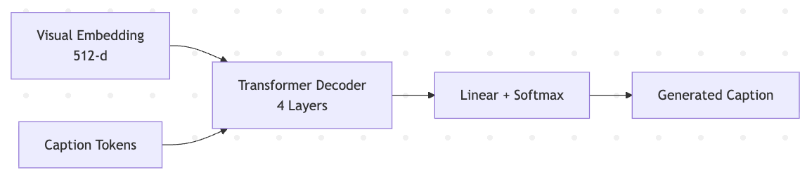
Figure 2: Transformer-based caption generation module.

Training Framework

Training Configuration
Component | Configuration
Loss | Cross-Entropy (ignore <PAD>)
Optimizer | AdamW
Learning Rate | 1e-4
Weight Decay | 1e-5
Scheduler | Cosine Annealing
Batch Size | 32
Epochs | 20–30
Early Stopping | Patience = 5
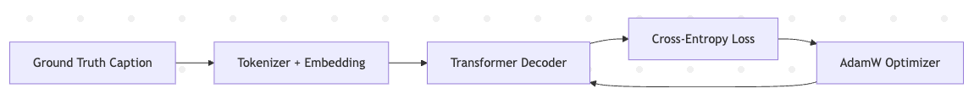
Figure 3 Training loop showing loss computation and optimization.

Validation and Evaluation

Evaluation Metrics
The model will be evaluated using:
- BLEU-1 and BLEU-4
- METEOR
- CIDEr
- SPICE

Acceptance Thresholds
- CIDEr ≥ 110
- BLEU-4 ≥ 35

Statistical Validation
- Mean ± Standard Deviation over 3 runs
- Optional paired t-test for baseline comparison
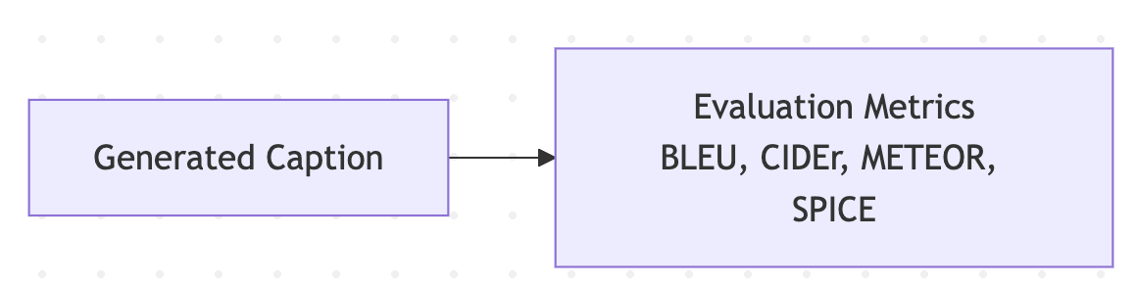
Figure 4 Evaluation framework for caption quality assessment.

Error Analysis and Interpretability

Failure Analysis
- Rare object omission
- Incorrect object relationships
- Caption hallucination

Interpretability Techniques
- Grad-CAM visualization
- Attention weight heatmaps
These techniques help analyze whether generated words align with correct image regions.

Deployment Strategy

Inference Pipeline
Figure 5 Inference pipeline for deployment.

Deployment Configuration
- REST API using Flask
- Docker containerization
- Cloud GPU inference
- Target latency < 500 ms

Timeline and Milestones
Week | Milestone
Week 1 | Dataset preparation
Week 2 | Baseline implementation
Week 3 | Training & tuning
Week 4 | Evaluation & analysis
Week 5 | Final optimization & documentation

Risk Assessment and Mitigation
Risk | Mitigation
Class imbalance | Data augmentation
Overfitting | Dropout + early stopping
Limited GPU | Transfer learning
Caption hallucination | Attention regularization
Overall System Architecture (Complete Flow)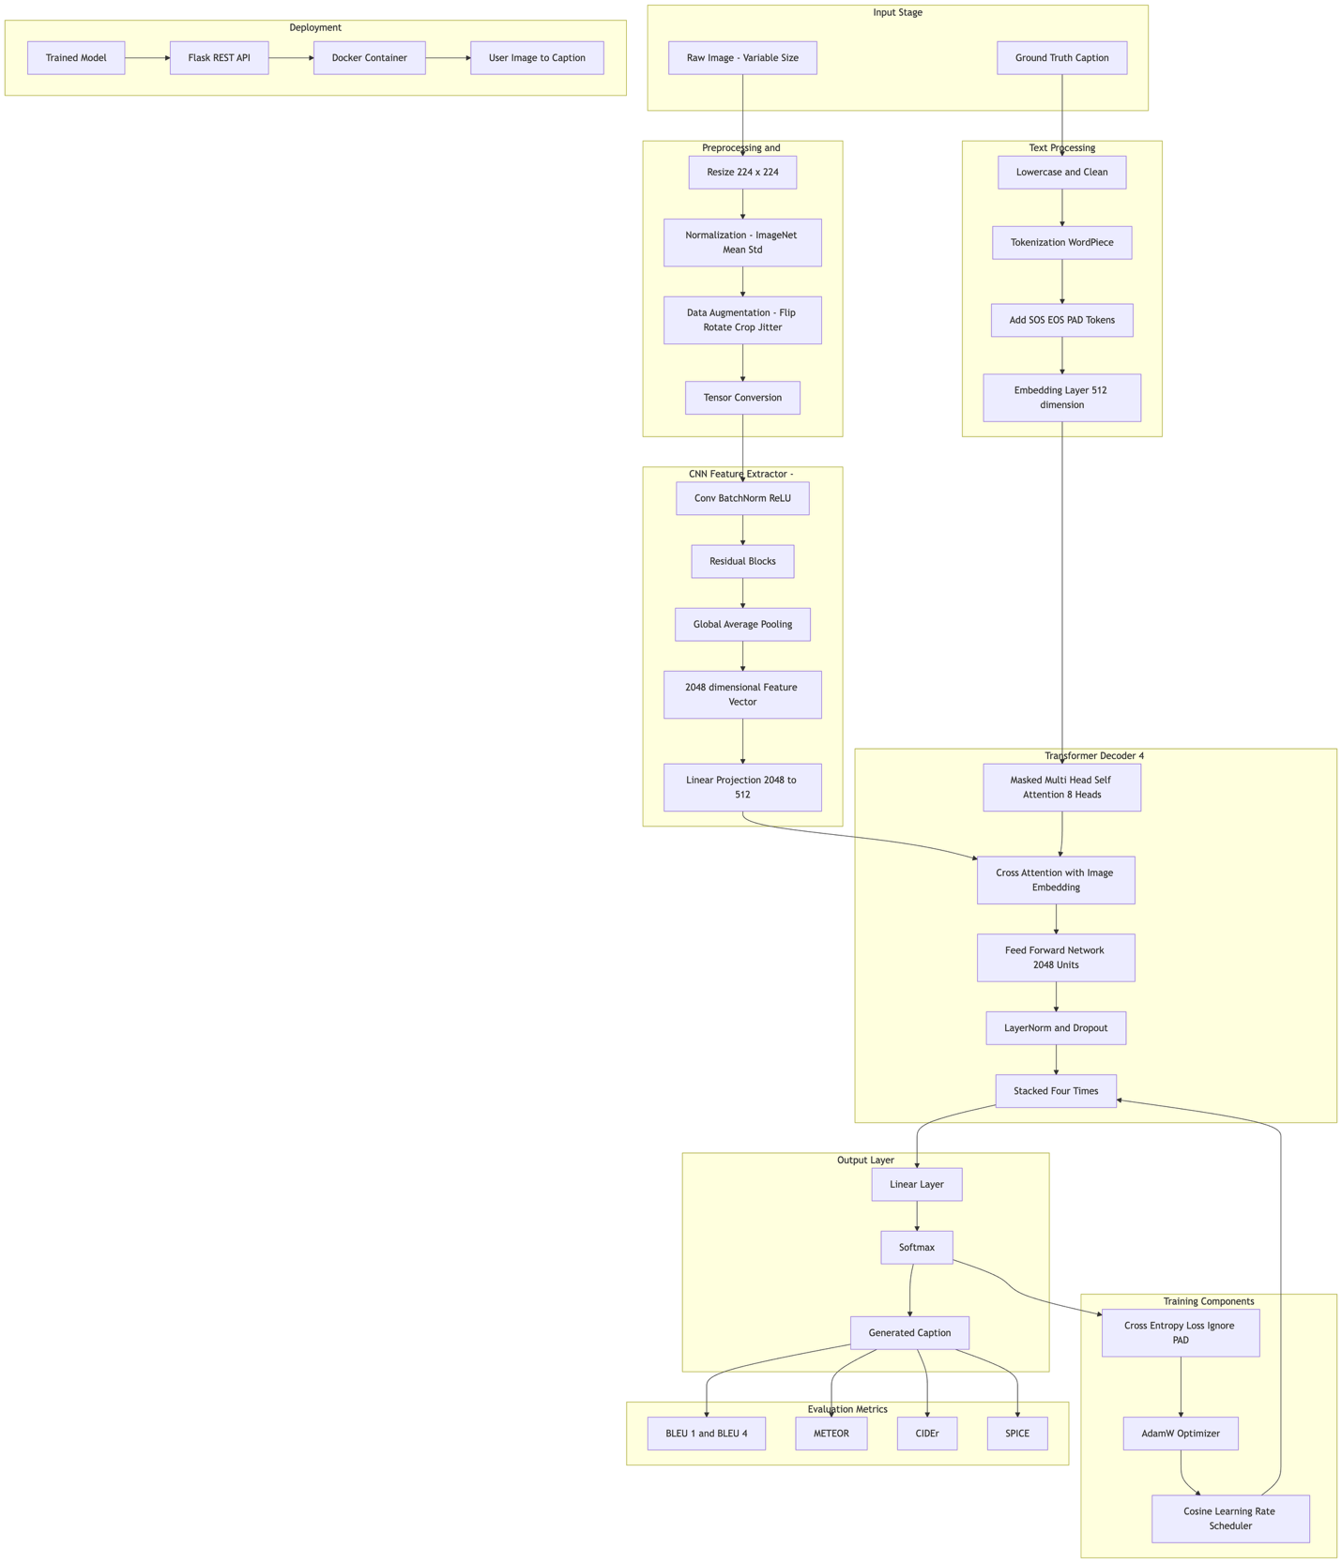
Figure 6 Complete hybrid CNN–Transformer image captioning architecture.

Conclusion
This proposed methodology presents a structured and computationally efficient hybrid CNN–Transformer framework for image captioning. By leveraging pretrained ResNet-50 for feature extraction and a lightweight Transformer decoder for caption generation, the model aims to balance performance and efficiency. The system integrates rigorous preprocessing, optimized training strategies, standardized evaluation metrics, interpretability analysis, and deployment planning to ensure academic rigor and practical applicability.

